

**SkyD**

**Customer Panel**

Contents

2 Introduction 3

3 Purpose 3

4 About Customer & Onboarding 3

5 Requirements 3

**5.1** Login 3

4.1.1 Forgot Password 5

4.1.2 OTP Verification 6

4.1.3 Reset Password 8

4.1.4 Sign Up 9

4.1.5 Profile Setup 11

**5.2** Men’s Page 13

# Introduction

SkyD is an online platform

# Purpose

Software Requirement Specification (SRS)

# About Customer & Onboarding

# Requirements

Customer’s requirements are defined below –

## Login

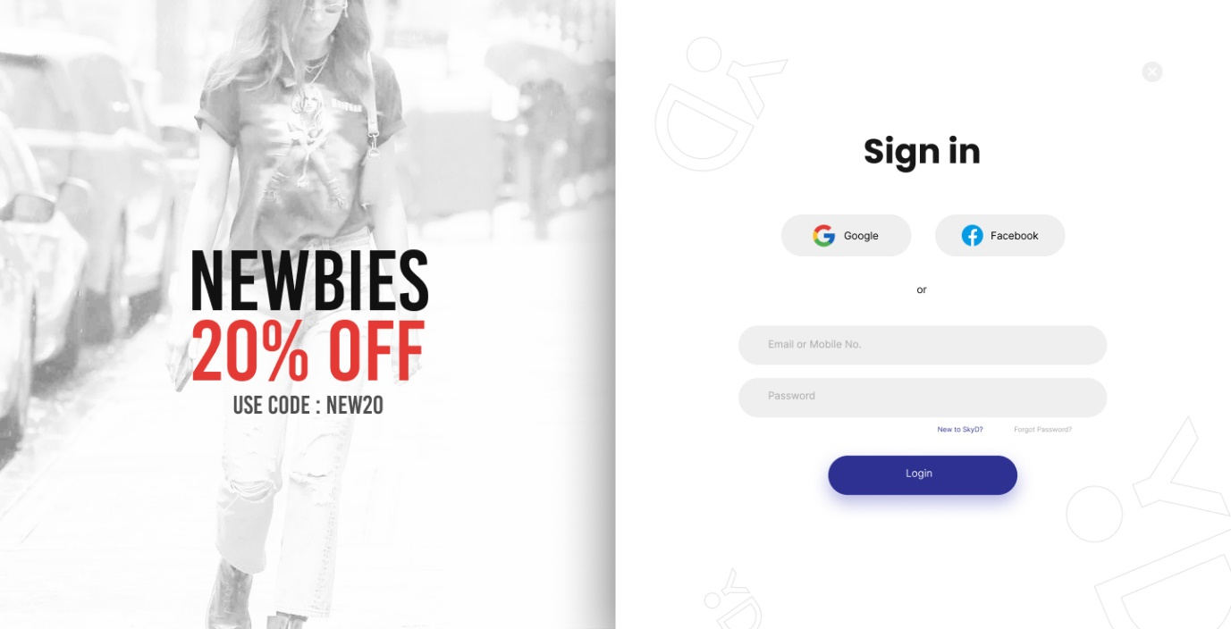

Previous Page:

* Any Screen

Description**:** User will be able to login to the Portal as a Customer using this option.

Pre-condition**:**

* User should have clicked on ‘Login’ Button from the Menu Header.
* User should have clicked on ‘Already have an Account? Login’ option from the Sign-up Page.

Business Rules:

* All fields are mandatory.
* User must enter their registered Email ID or Mobile Number.
* Password should match the current Password of the user.
* If user enters an incorrect ID/ Mobile Number or Password and clicks on Login button then they should be shown an error stating ‘The email ID/ Mobile Number or Password is incorrect.’

Actions:

**Sign in using Google Account (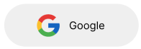)**

* Users will be able to sign in to the portal using their Gmail Account from this option.
* When a user clicks on this button, they will be able to login into the Portal using their registered Gmail Account.
* If the user is not registered and they click on this option then they will be able to sign up and setup their Profile.

**Sign in using Facebook Account (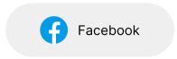)**

* Users will be able to sign in to the portal using their Facebook Account from this option.
* When a user clicks on this button, they will be able to login into the Portal using their registered Facebook Account.
* If the user is not registered and they click on this option then they will be able to sign up and setup their Profile.

**View/ Hide Password (https://lh5.googleusercontent.com/ZeW-tsjgmArEoYuWwZ1v30kxY5fapV5gqfks9URfkpGvaePk2OuEPC8g2jRRVFmMBDzXxofOzjS6oa1InBcPqA_2_--8j2iOe3iTppV6kYSB94NLL20K2mt0K8vuWDKgkqWL_-7lzeDtpHuG753C-w)**

* User can see their password while typing if they click on this option.
* By default, the password will be hidden.

**New to SkyD/ Sign Up (****)**

* Users will be able to Sign up into SkyD Site using this option.
* When they click on this option, they will be redirected to the Sign-up Page.

**Forgot Password (https://lh6.googleusercontent.com/r4FXVktvnl8Bf3Y4PAuNKGIPbN5Q_invjQdUwUyLTFWeGTNaPPY2L536uAXEh5rHqVvtnJ_nSrvIrlKH18BqNMURZGqlA7kD45CUb2A_4ZevfQGB6sJ8m3Gcn54_th44HNFyHf7NA_QzwfJn965qKw)**

* User will be redirected to the Forgot Password screen once they click on this option.

**Remember Me (https://lh5.googleusercontent.com/iZRp0gi9z093IKoQPZSCxU-EbbaPvj6ElpOFabTvm22PL4QJTUuvZNUbFuBvwuHGGqKoHp8U7nWv9dd_PyjH91RzyLAvgPdKq7IN-Ms_WYq8g_I3lF2O0t9ChZ4_fAhTeDITmcjyGztbry0x5Qdt1A)**

* This will allow Users to stay logged in when they access the account again even if they close the browser.

**Login Button (****)**

* User will be able to click on this button once they correctly enter their registered Email ID and Password.
* If the ID/ Mobile Number or Password is incorrect then the user will be shown an error.

**Cancel (****)**

* If user clicks on this icon then the login will be cancelled and they will be redirected back to the page they came from.

Post-condition:

* If user have correctly entered their credentials and they click on Login button, they will be logged in and redirected to the same page they came from with additional access to their Accounts Page.
* If the user has incorrectly entered their credentials and they click on the login button then they will remain on the same page and an error will be shown to them as mentioned above.
* In case of any unsuccessful sign in attempt or upon any validation rule(s) violation, an appropriate error message needs to be displayed using an alert dialogue box.

Next Screen:

* Previous Screen (if successfully signed in)
* Forgot Password Page – If user clicks on ‘Forgot password?’ option.
* Sign Up screen – If user clicks on ‘New to SkyD?’ option.
* Error Screen – If user fails any validation errors.

### Forgot Password

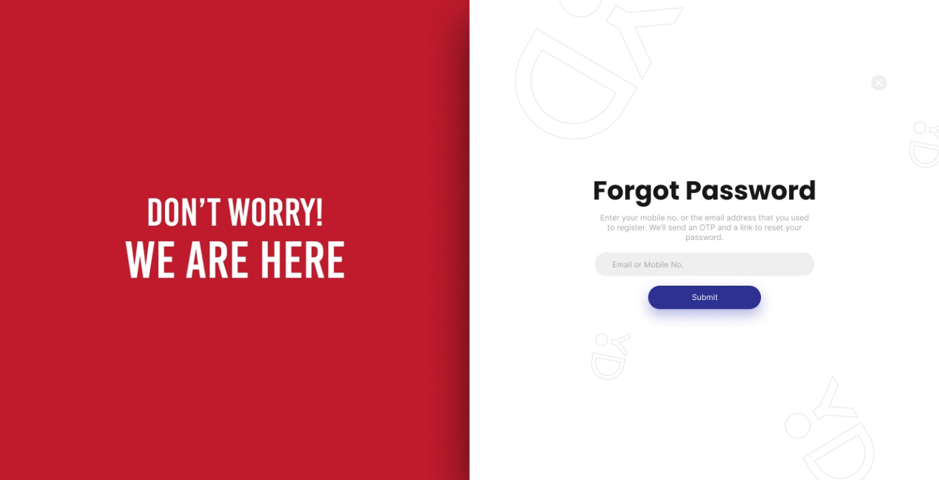

Previous Page:

* Login

Description**:** User will be able to retrieve their Forgotten Password from this option.

Pre-condition**:**

* User should have clicked on ‘Forgot Password?’ Link from the Login Page.
* User should have forgotten their Password.

Business Rules:

* User must enter their registered Email ID or Mobile Number in order to retrieve a Password.
* If the Email ID or Mobile Number is not registered then they should get the following error message ‘Email ID or Mobile Number is not registered. Please enter a valid ID.’

Actions:

**Submit Button (****)**

* User will be able to click on this button once they correctly enter their registered Email ID or Mobile Number so that they can receive an OTP.
* If the ID/ Mobile Number is incorrect then the user will be shown an error.

**Cancel (****)**

* If user clicks on this icon then they will be redirected back to the Login page.

Post-condition:

* If user have correctly entered their ID/ Mobile Number and they click on Submit button, they will be logged in and redirected to the OTP Verification Page.
* If the user has incorrectly entered their ID/ Mobile no and they click on the Submit button then they will remain on the same page and an error will be shown to them as mentioned above.
* In case of any unsuccessful sign in attempt or upon any validation rule(s) violation, an appropriate error message needs to be displayed using an alert dialogue box.

Next Screen:

* OTP Verification
* Error Screen – If user fails any validation errors.

### OTP Verification

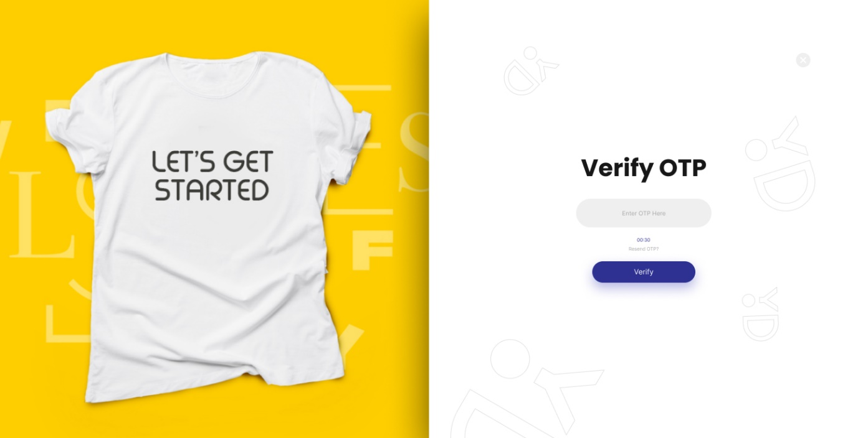

Previous Page:

* Forgot Password

Description**:** User will be able to enter OTP from this option received on their registered ID/ Mobile number.

Pre-condition**:**

* User should have clicked on ‘Submit’ Button from the Forgot Password Page.
* User must have entered their registered Mobile Number/ Email address from Forgot Password Page.

Business Rules:

* User must receive a 6-digit OTP on their registered mobile number/ email address for the verification.
* OTP entered here must match the OTP received.
* The user can ask for a new OTP which can be done by tapping on the ‘Resend’ OTP link after 30 seconds of sending the previous OTP.
* Users can click on Resend OTP as many times as they want to.
* Users will not be able to set a new password unless they verify their Mobile number/ email address.

Actions:

**Resend OTP (****)**

* User will be able to click on this button and they will receive a new OTP on their registered Email ID/ Mobile Number.

**Verify Button (****)**

* User will be able to click on this button once they correctly enter OTP received.
* If the OTP is incorrect then the user will be shown an error.

**Cancel (****)**

* If user clicks on this icon then they will be redirected back to the Forgot Password page.

Post-condition:

* If user have correctly entered the OTP and they click on Verify button, they will be redirected to the Reset Password Page.
* If the user has incorrectly entered OTP and they click on the Verify button then they will remain on the same page and an error will be shown to them as mentioned above.
* In case of any unsuccessful sign in attempt or upon any validation rule(s) violation, an appropriate error message needs to be displayed using an alert dialogue box.

Next Screen:

* Reset Password
* Error Screen – If user fails any validation errors.

### Reset Password

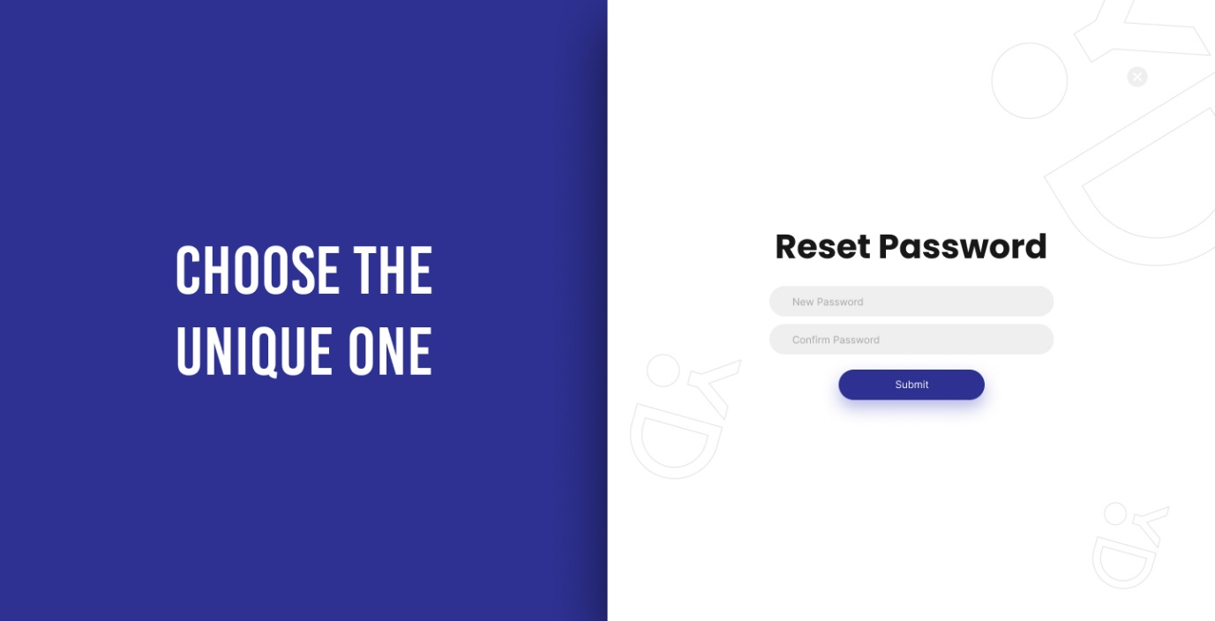

Previous Page:

* Forgot Password

Description**:** User will be able to change their Password from this option.

Pre-condition**:**

* User should have clicked on ‘Verify’ Button from the OTP Verification Page after entering the correct OTP.

Business Rules:

* New Password can not be same as Old Password.
* Both New Password and Confirm Password are mandatory field.
* New Password must contain the following –
  + Atleast 1 uppercase character
  + Atleast 1 lowercase character
  + Atleast 1 Special Character (@, #, &, etc.)
  + Atleast 1 number
  + The password must be atleast 8 characters Long
* Confirm Password must match the New Password.

Actions:

**Submit Button (****)**

* User will be able to click on this button once they enter their new password.
* If there are validation errors then same will be shown as an error message.

**Cancel (****)**

* If user clicks on this icon then they will be redirected back to the Forgot Password page.

Post-condition:

* If user have correctly entered the New password and they click on Submit button, they will be redirected to the Home Page.
* In case of any unsuccessful sign in attempt or upon any validation rule(s) violation, an appropriate error message needs to be displayed using an alert dialogue box.

Next Screen:

* Homepage
* Error Screen – If user fails any validation errors.

### Sign Up

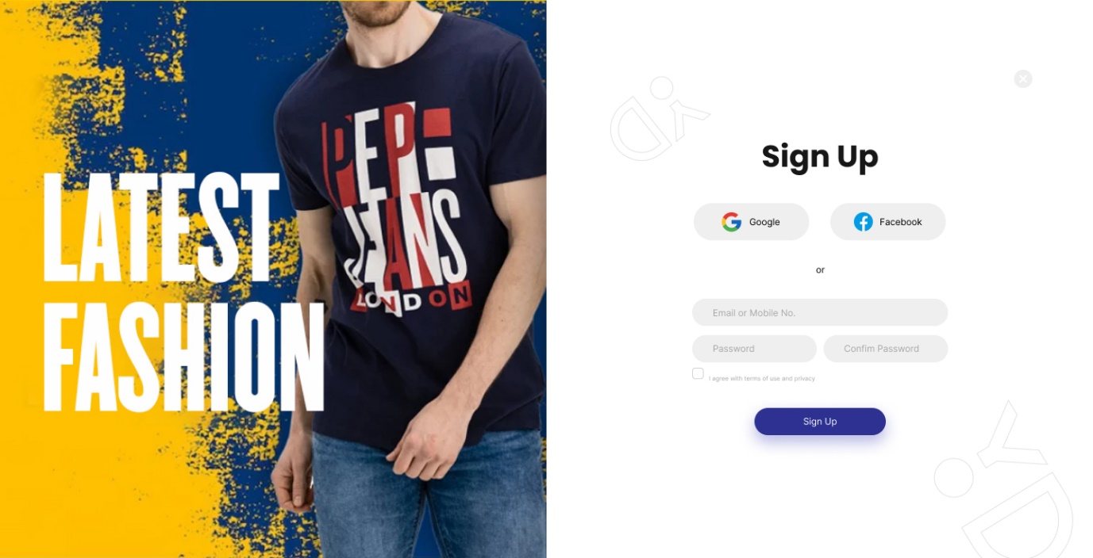

Previous Page:

* Login

Description**:** User will be able to register into the Portal using this option.

Pre-condition**:**

* User should have clicked on ‘New to SkyD?’ from the Login Page.
* User must not be already registered in the Portal.

Business Rules:

* User can either sign up using Email ID of Mobile Number.
* The following fields are mandatory –
  + Email ID or Mobile Number
  + Password
  + Confirm Password
* Email ID must end with @domain.com and must have the basic Email ID checks.
* Mobile number must be only 10 Digits.
* In case of Email ID, User will be able to set their Password
* In case of Mobile Number, User can login using OTP.
* Password must contain the following –
  + Atleast 1 uppercase character
  + Atleast 1 lowercase character
  + Atleast 1 Special Character (@, #, &, etc.)
  + Atleast 1 number
  + The password must be atleast 8 characters Long
* Confirm Password must match the Password.

Actions:

**Sign up using Google Account ()**

* Users will be able to sign up to the portal using their Gmail Account from this option.
* When a user clicks on this button, they will be able to signup successfully and setup their profile.

**Sign up using Facebook Account ()**

* Users will be able to sign up to the portal using their Facebook Account from this option.
* When a user clicks on this button, they will be able to signup successfully and setup their profile.

**TnC (****)**

* User must click on this checkbox in order to Signup in the Portal.

**Sign Up Button (****)**

* User will be able to click on this button and Signup into the Portal.

**Cancel (****)**

* If user clicks on this icon then they will be redirected back to the Login page.

Post-condition:

* If user have correctly entered all the required details, then they will be redirected to the Profile Setup Page.
* In case of any unsuccessful attempt(s) or upon any validation rule(s) violation, an appropriate error message needs to be displayed using an alert dialogue box.

Next Screen:

* Profile Setup Page
* Error Screen – If user fails any validation errors.

### Profile Setup

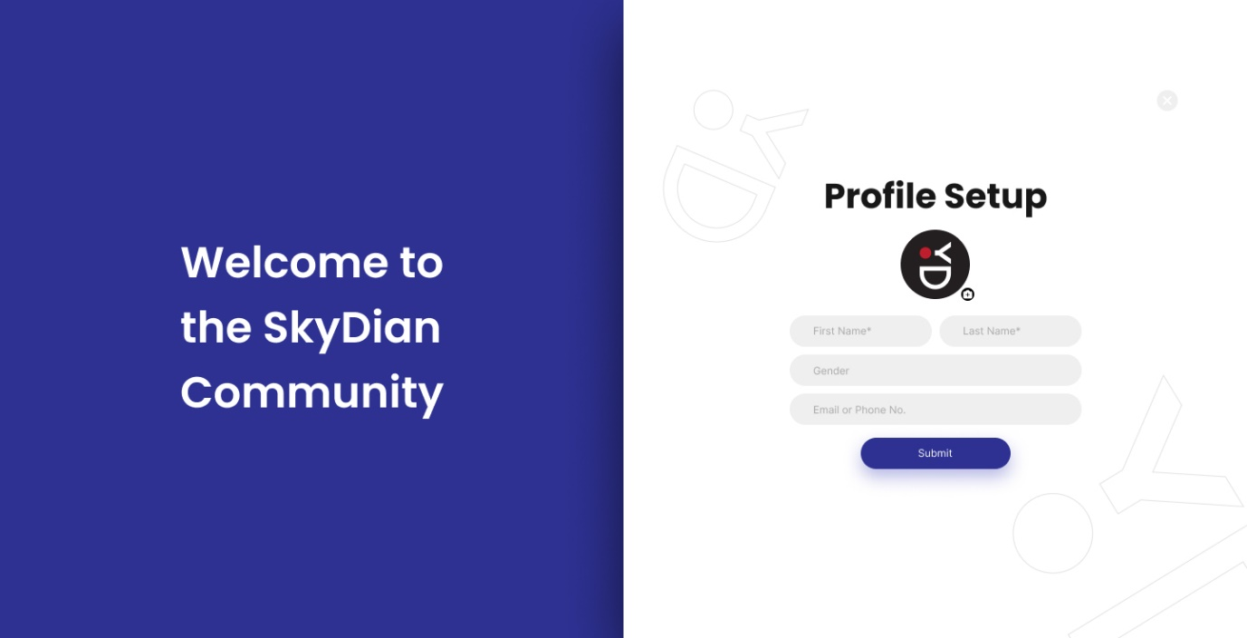

Previous Page:

* Signup

Description**:** User will be able to setup their Profile using this page.

Pre-condition**:**

* User should have successfully signed up on the Portal.

Business Rules:

* User cannot skip this Page and is mandatory when user signs up.
* First Name and Last Name fields will have following Validations –
  + They are mandatory fields.
  + User can only enter text in the fields.
  + Character Limit – 25 characters
* Gender will have following Validations –
  + It is a Non-Mandatory field.
  + It will be a dropdown field with the following values –
    - Male
    - Female
    - Others
* Email or Mobile Number will have following Validations –
  + It is a Non-Mandatory field.
  + If user has signed up using Email ID then only Mobile Number should be asked during Profile setup.
  + If user has signed up using Mobile Number then only Email ID should be asked during Profile setup.

Actions:

**Submit Button (****)**

* User will be able to click on this button and their entered data will be saved.
* If there are validation errors then same will be shown as an error message.

Post-condition:

* If user have correctly entered all the required details, then they will be redirected to the Page they’ve come from.
* In case of any unsuccessful attempt(s) or upon any validation rule(s) violation, an appropriate error message needs to be displayed using an alert dialogue box.

Next Screen:

* Any Page
* Error Screen – If user fails any validation errors.

## Men’s Page

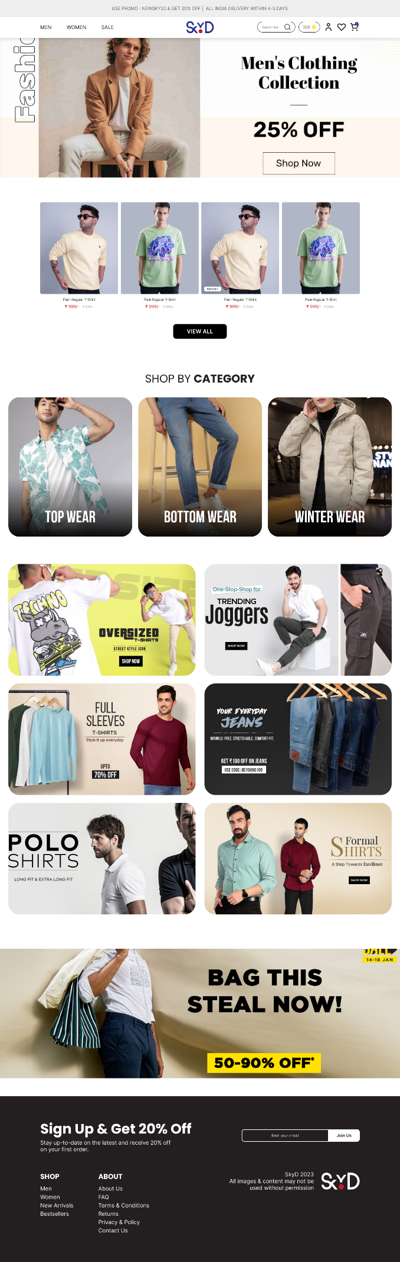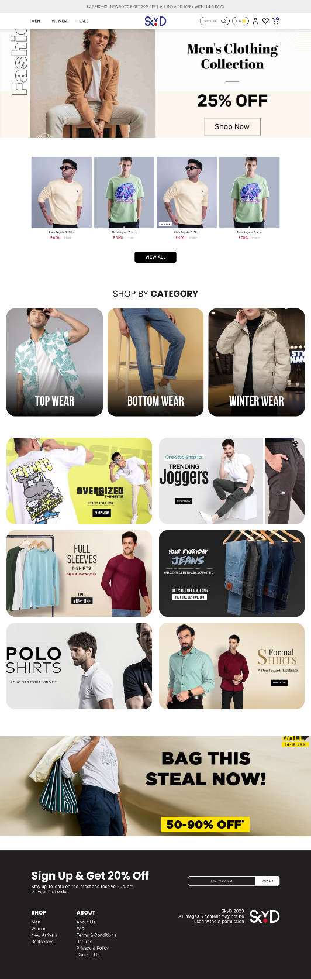

Previous Page:

* Any Page

Description**:** User will be able to view various offers/ options available for Men in the Portal.

Pre-condition**:**

* User should have clicked on ‘Men’ from the Navigation Menu.

Business Rules:

* **Banner**
  + There can only be one Banner.
  + There will be a Button on the Banner clicking upon which the user will be redirected to the Link assigned by the Admin from Backend.
  + Admin should be able to change the Banner from Backend.
* **Featured Products**
  + Admin should be able to select the Products which will be shown to the users on the Men’s page.
  + Only 4 Products can be shown to the customer from the Featured Products.
  + User will have a Button to ‘View All’ product clicking upon which user will be redirected to ‘All Products’ Listing for Men.
  + Users will be able to view the following details of the Featured Products –
    - Product Cover Image
    - Product Name
    - Price
    - Discounted Price
  + If user clicks on any Product then they will be redirected to the Product details Page.
* **Shop by Category**
  + Users will be able to view all categories available in Men’s Wear from this option.
  + Shop by Category will have the Following –
    - Category Cover Image
    - Category Name
  + Admin should be able to change the Category Cover Image and Name from the Backend.
  + If user clicks on a Category then they will be redirected to the Category Product Listing Page.
* **Featured Banners**
  + Users will be able to view Featured Banner Added by Admin from this option.
  + They can only view 6 Banners from the Page.
  + If a user clicks on a banner then they will be redirected to the Link as per assigned by the Admin.
* **Offers Banner**
  + Users will be able to view the Offers banner at the bottom of the Page.
  + This can be changed by the Admin.
  + If a user clicks on the banner then they will be redirected to the Link as per assigned by the Admin.
  + There can only be 1 banner for offers.

Actions:

**Shop Now (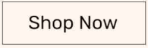)**

* Users will be redirected to the Product Listing curated by the Admin.

**View All (****)**

* Users will be able redirected to ‘All Products’ Listing for Men.

Post-condition:

* User should be redirected to the pages as mentioned above.

Next Screen:

* Product Listing